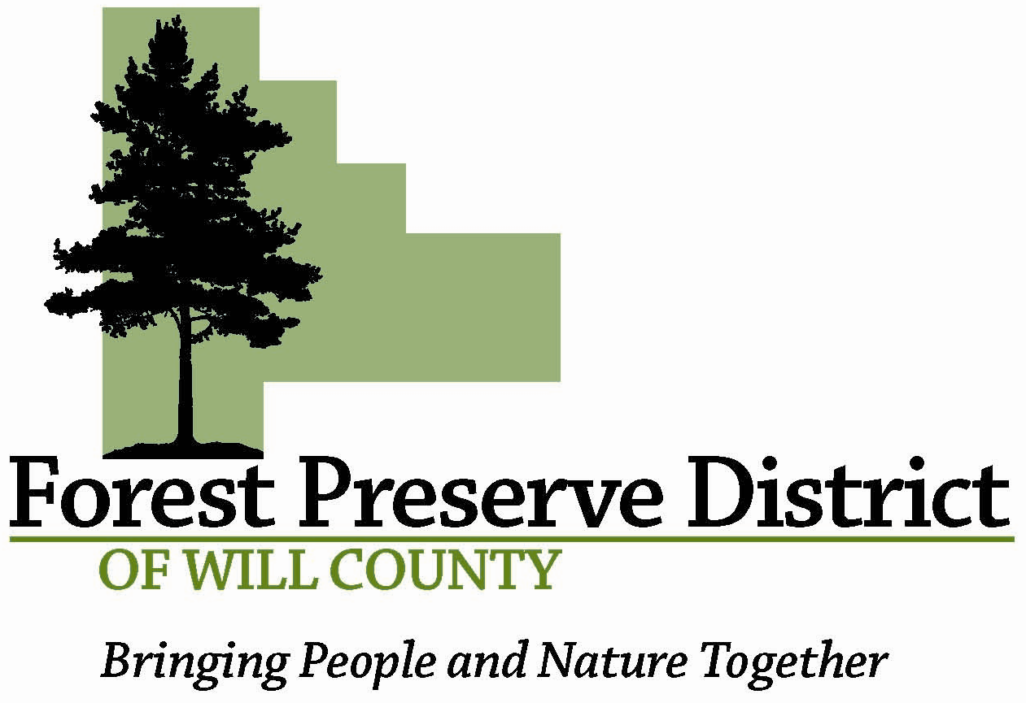

WAIVER & RELEASE (SURVIVAL PROGRAM)

IMPORTANT INFORMATION
The Forest Preserve District of Will County (FPDWC) is committed to conducting its programs and activities in a safe manner and holds the safety of participants in high regard. The FPDWC continually strives to reduce such risks and insists that all participants follow safety rules and instructions that are designed to protect the participants’ safety and read and understand safety protocol prior to start of activity. However, participants and parents/guardians of minors registering for this program must recognize that there is an inherent risk of injury when choosing to participate in activities.

You are solely responsible for determining if you or your minor child/ward is physically fit and/or adequately skilled for the activities contemplated by this agreement. It is always advisable, especially if the participant is pregnant, disabled in any way or recently suffered an illness, injury or impairment, to consult a physician before undertaking any physical activity.

WARNING OF RISK
Workdays and activities may challenge and engage the physical, mental and emotional resources of each participant. However, despite careful and proper preparation, instruction, medical advice, conditioning and equipment, there is still a risk of serious injury, including but not limited to head/brain injury, cervical spine injury (including quadriplegia) and death. Understandably, not all hazards and dangers can be foreseen. Because work days put a great demand on stamina, the very nature of the work days and activities may be hazardous and risky. Such risks and dangers include but are not limited to the acts of over exertion due to over-lifting and cold it must be recognized that it is impossible for the FPDWC to guarantee absolute safety.

WAIVER AND RELEASE OF ALL CLAIMS AND ASSUMPTION OF RISK
Please read this form carefully and be aware that in signing up and participating in this workday/activity, you will be expressly assuming the risk and legal liability and waiving and releasing all claims for injuries, damages or loss which you or your minor child/ward might sustain as a result of participating in any and all activities connected with and associated with this workday/activity (including transportation services, when provided).

I recognize and acknowledge that there are certain risks of physical injury to participants in workdays or activities, and I voluntarily agree to assume the full risk of any injuries, damages or loss, regardless of severity that my minor child/ward or I may sustain as a result of participating in any and all activities connected with or associated with this workday/activity. I further agree to waive and relinquish all claims I or my minor child/ward may have (or accrue to me or my child/ward) as a result of participating in this workday/activity against the FPDWC, including its volunteers and employees (hereinafter collectively referred as “Parties”).

I do hereby fully release and forever discharge the Parties from any and all claims for injuries, damages or loss that my minor child/ward or I may have or which may accrue to me or my minor child/ward and arising out of, connected with, or in any way associated with this workday/activity.

I have read and fully understand the above important information, warning of risk, assumption of risk and waiver and release of all claims. If registering on-line or via fax, your on-line or facsimile signature shall substitute for and have the same legal effect as an original form signature.
PLEASE PRINT All Participant (s) Name (s) and Address

Date____________________ ______________________________________________________

______________________________________________________

______________________________________________________
Please Print
Participant
or Guardian Signature ______________________________________________________
(18 years or older or Parent/Guardian
PARTICIPATION WILL BE DENIED
If the signature of adult participant or parent/guardian and date are not on this waiver.

